Chapter 12, Problem 25.

In the circuit of Fig. 12.54, if V_{ab} = 440 ∠10°, V_{bc} = 440∠250°,
V_{ca} = 440 ∠130° V, find the line currents.

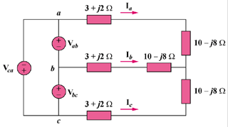

Figure 12.54
For Prob. 12.25.

